Point on a solid's surface

Definition
# Source: AI Source: Provided by: [Data Path: Persons Table -> ID Column: 1, Name_En Column: Motasem Essam] -> From: [ChatGPT] on [7/25/2026]
A point on a solid's surface is a point located exactly on the external boundary of a three-dimensional solid, separating its interior from the surrounding space.
A point in three-dimensional space is represented by coordinates $\left(x,y,z\right)$. Whether a point lies on a solid's surface depends on the equation or geometric conditions defining that surface.
For example, a point $P\left(x,y,z\right)$ lies on the surface of a sphere centered at the origin with radius $r$ if
$$x^{2}+y^{2}+z^{2}=r^{2}$$
Unlike a point inside a solid, a surface point belongs to the solid's boundary rather than its interior.

Simple Definition
# Source: AI Source: Provided by: [Data Path: Persons Table -> ID Column: 1, Name_En Column: Motasem Essam] -> From: [ChatGPT] on [7/25/2026]
A point on a solid's surface is a point located exactly on the outside of a three-dimensional object, such as a point on a cube's face or on a sphere's curved surface.
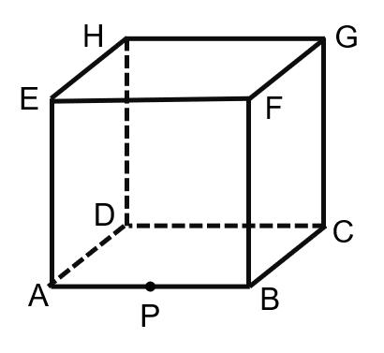
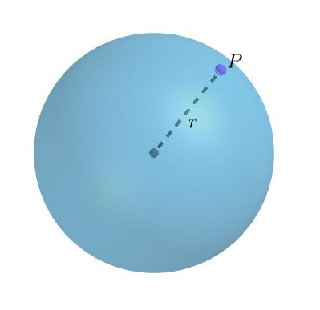
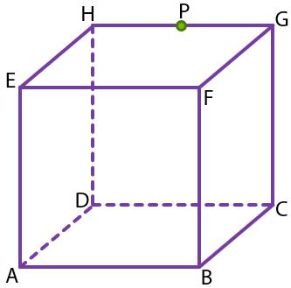

Key Characteristics
# Source: AI Source: Provided by: [Data Path: Persons Table -> ID Column: 1, Name_En Column: Motasem Essam] -> From: [ChatGPT] on [7/25/2026]
- Zero-dimensional: A point has no length, width, or height.
- Boundary location: It lies on the external boundary of a solid.
- Three-dimensional coordinates: Its position can be represented by $\left(x,y,z\right)$.
- Shape-dependent conditions: Its coordinates must satisfy the equations or inequalities defining the relevant surface.
- Separates interior from exterior: For an ordinary closed solid, the surface forms the boundary between the solid's interior and its exterior.
- May belong to multiple faces: For example, a cube's edge belongs to two faces, while a vertex belongs to several faces.

Types of Points on a Solid's Surface

1. Point on a Flat Face
# Source: AI Source: Provided by: [Data Path: Persons Table -> ID Column: 1, Name_En Column: Motasem Essam] -> From: [ChatGPT] on [7/25/2026]
A point on a flat face lies on one of the polygonal surfaces forming a polyhedron, such as a cube, cuboid, prism, or pyramid.
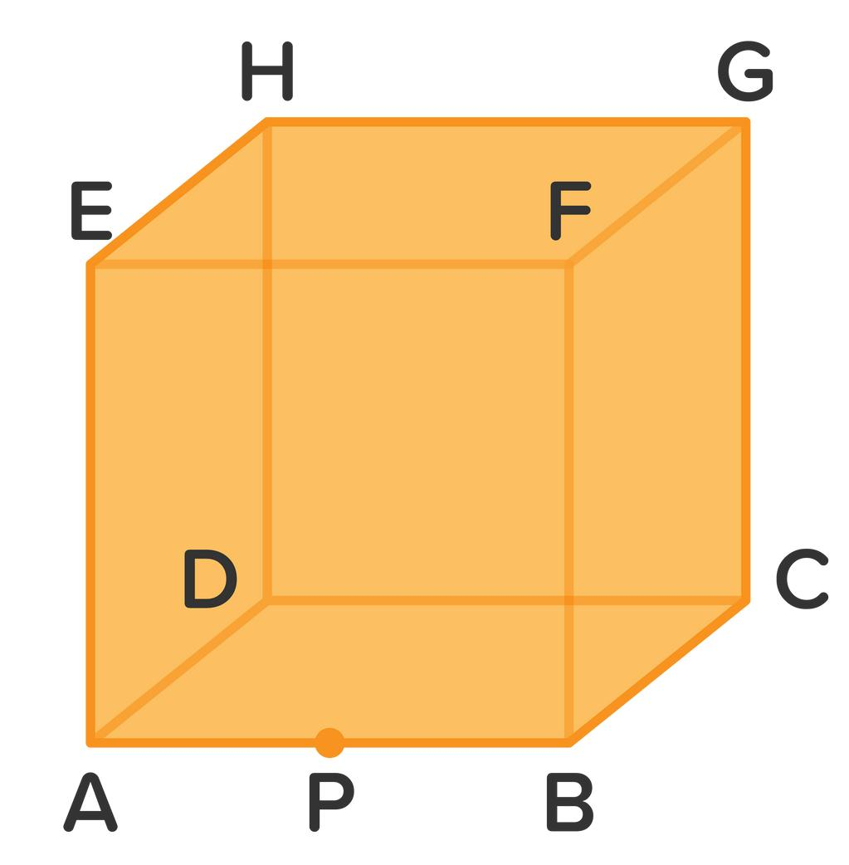
For a cube occupying $0≤x,y,z≤4$, consider its top face:
$$z=4, 0≤x,y≤4$$
The point $P\left(2,3,4\right)$ lies on this face because it satisfies the face equation and falls within the face's boundaries.
Examples:
- A point on a cube's top face.
- A point on a cuboid's side face.
- A point on a triangular prism's rectangular face.
- A point on a pyramid's triangular face.

2. Point on a Curved Surface
# Source: AI Source: Provided by: [Data Path: Persons Table -> ID Column: 1, Name_En Column: Motasem Essam] -> From: [ChatGPT] on [7/25/2026]
A point on a curved surface lies on the external curved boundary of a solid, such as a sphere, cylinder, cone, or ellipsoid.
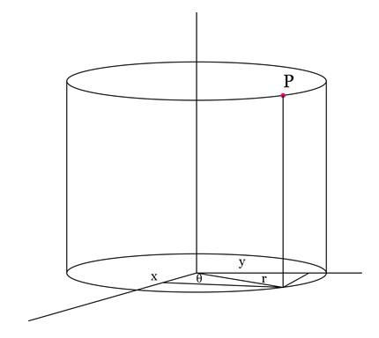
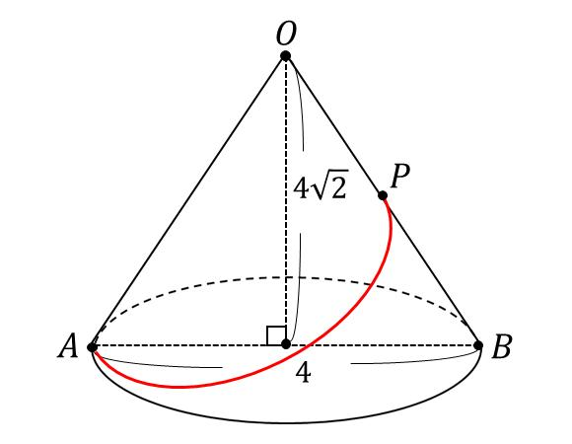
For a sphere centered at the origin with radius $r$, a point lies on the surface when
$$x^{2}+y^{2}+z^{2}=r^{2}$$
For a right circular cylinder with radius $r$ whose axis is the $z$-axis, a point on the curved lateral surface satisfies
$$x^{2}+y^{2}=r^{2}$$
with its $z$-coordinate within the cylinder's height.
Examples:
- A point on a sphere's outer surface.
- A point on the curved side of a cylinder.
- A point on a cone's lateral surface.
- A point on an ellipsoid's surface.

3. Point on an Edge
# Source: AI Source: Provided by: [Data Path: Persons Table -> ID Column: 1, Name_En Column: Motasem Essam] -> From: [ChatGPT] on [7/25/2026]
An edge is where two faces of a polyhedron meet. A point on an edge is therefore also a point on the solid's surface.
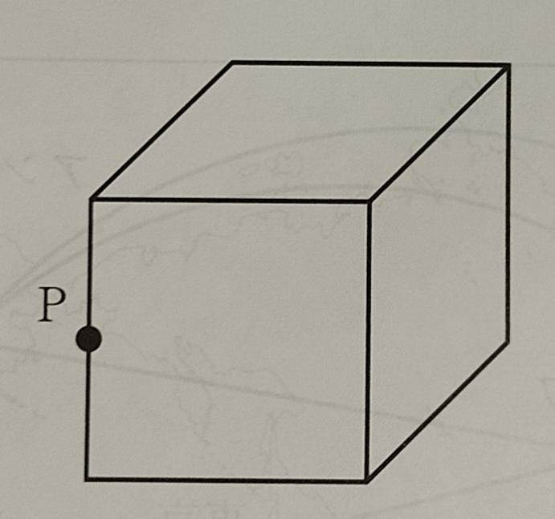
For a cube with $0≤x,y,z≤4$, consider the edge defined by
$$x=4, y=4, 0≤z≤4$$
The point $P\left(4,4,2\right)$ lies on this edge.
An edge point is also on the two adjacent faces that meet along that edge.

4. Point at a Vertex
# Source: AI Source: Provided by: [Data Path: Persons Table -> ID Column: 1, Name_En Column: Motasem Essam] -> From: [ChatGPT] on [7/25/2026]
A vertex is a corner of a polyhedron where its edges meet. A point located at a vertex is also on the solid's surface.
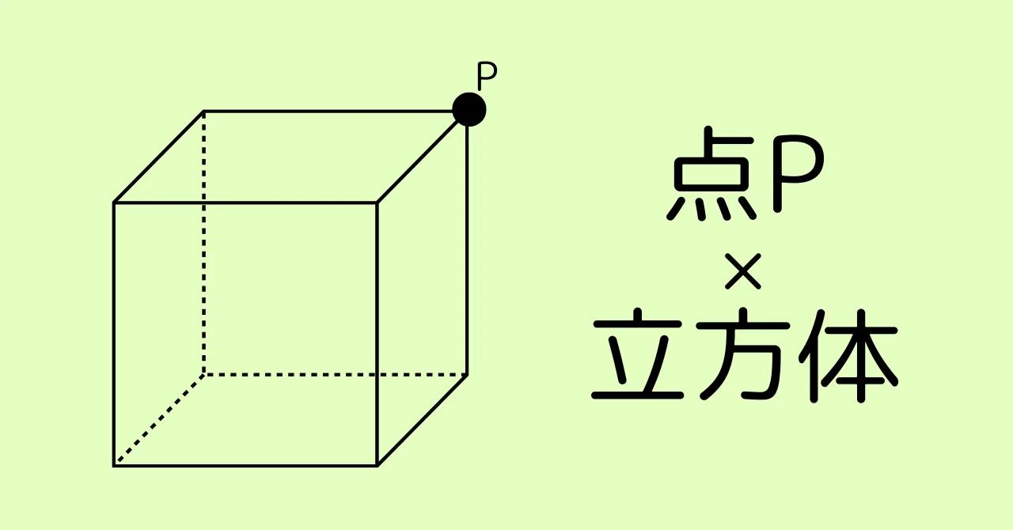
For a cube occupying $0≤x,y,z≤4$, the point
$$P\left(4,4,4\right)$$
is one of its vertices.
A vertex is a special surface location because multiple edges and faces meet there.

5. Point on a Composite Solid's Surface
# Source: AI Source: Provided by: [Data Path: Persons Table -> ID Column: 1, Name_En Column: Motasem Essam] -> From: [ChatGPT] on [7/25/2026]
A composite solid is formed by combining two or more simple solids. Its external surface may contain several types of surfaces, including flat faces and curved surfaces.
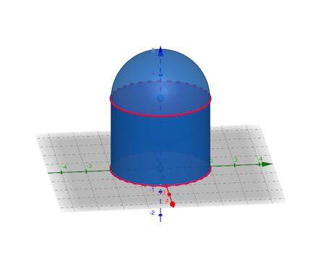
For example, consider a cylinder joined to a hemisphere. A point on the exposed cylindrical side or the exposed hemispherical surface lies on the external boundary of the combined solid.
Important distinction: The joining surface between the two components is generally an internal interface, not part of the composite solid's external surface.

Mathematical Representation

1. General condition
# Source: AI Source: Provided by: [Data Path: Persons Table -> ID Column: 1, Name_En Column: Motasem Essam] -> From: [ChatGPT] on [7/25/2026]
Let $S$ be a solid and $∂S$ denote its boundary. A point $P$ lies on the solid's surface when
$$P∈∂S$$
For a regular closed solid, the boundary separates its interior from the exterior.

2. Surface equations and conditions
# Source: AI Source: Provided by: [Data Path: Persons Table -> ID Column: 1, Name_En Column: Motasem Essam] -> From: [ChatGPT] on [7/25/2026]
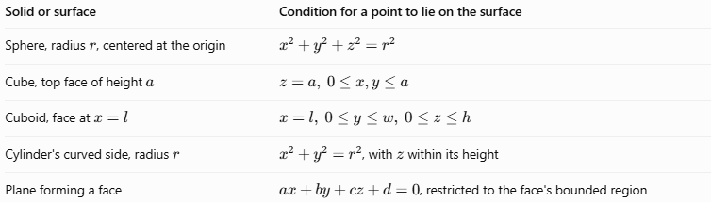
Solid or surface | Condition for a point to lie on the surface
Sphere, radius $r$, centered at the origin | $$x^{2}+y^{2}+z^{2}=r^{2}$$
Cube, top face of height $a$ | $$z=a, 0≤x,y≤a$$
Cuboid, face at $x=l$ | $$x=l, 0≤y≤w, 0≤z≤h$$
Cylinder's curved side, radius $r$ | $x^{2}+y^{2}=r^{2}$, with $z$ within its height
Plane forming a face | $ax+by+cz+d=0$, restricted to the face's bounded region
For a polyhedron, satisfying a face's plane equation alone is not sufficient to establish that a point lies on the face: the point must also lie within the face's boundaries.

Worked Examples
# Source: AI Source: Provided by: [Data Path: Persons Table -> ID Column: 1, Name_En Column: Motasem Essam] -> From: [ChatGPT] on [7/25/2026]
Example 1: Point on a sphere
A sphere is centered at the origin and has radius $5$. Determine whether $P\left(3,0,4\right)$ lies on its surface.
Substitute the coordinates:
$$3^{2}+0^{2}+4^{2}=9+16=25$$
Since
$$25=5^{2}$$
Answer: $P\left(3,0,4\right)$ lies on the sphere's surface.
Example 2: Point on a cube's face
A cube occupies $0≤x,y,z≤6$. Determine whether $Q\left(2,5,6\right)$ lies on its top face.
The top face satisfies $z=6$, and both $x=2$ and $y=5$ lie between $0$ and $6$.
Answer: $Q\left(2,5,6\right)$ lies on the top face.
Example 3: Point on an edge
Consider the cube $0≤x,y,z≤4$ and the point $R\left(4,4,2\right)$.
Because $x=4$ and $y=4$, while $z$ lies between $0$ and $4$, the point satisfies the conditions of a cube edge.
Answer: $R$ lies on an edge and therefore on the solid's surface.
Example 4: Distinguishing surface and interior points
A sphere centered at the origin has radius $3$. Consider $A\left(1,1,1\right)$ and $B\left(3,0,0\right)$.
For $A$:
$$1^{2}+1^{2}+1^{2}=3<9$$
So $A$ is inside the sphere.
For $B$:
$$3^{2}+0^{2}+0^{2}=9$$
So $B$ lies on the sphere's surface.

Comparison with Related Concepts
# Source: AI Source: Provided by: [Data Path: Persons Table -> ID Column: 1, Name_En Column: Motasem Essam] -> From: [ChatGPT] on [7/25/2026]
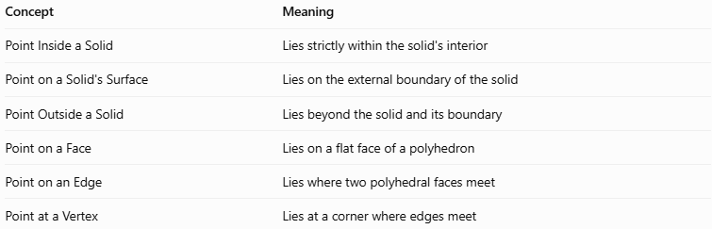
Concept | Meaning
Point Inside a Solid | Lies strictly within the solid's interior
Point on a Solid's Surface | Lies on the external boundary of the solid
Point Outside a Solid | Lies beyond the solid and its boundary
Point on a Face | Lies on a flat face of a polyhedron
Point on an Edge | Lies where two polyhedral faces meet
Point at a Vertex | Lies at a corner where edges meet

Applications
# Source: AI Source: Provided by: [Data Path: Persons Table -> ID Column: 1, Name_En Column: Motasem Essam] -> From: [ChatGPT] on [7/25/2026]
- 3D modeling: Identifying points on the outer surface of digital objects.
- Computer graphics: Detecting surface intersections and rendering visible points.
- Engineering: Locating measurements on manufactured components.
- Architecture: Identifying positions on walls, floors, and other solid boundaries.
- Computational geometry: Testing whether a point belongs to a solid's boundary.
- Physics: Describing locations on the surfaces of physical objects.

Key Points
# Source: AI Source: Provided by: [Data Path: Persons Table -> ID Column: 1, Name_En Column: Motasem Essam] -> From: [ChatGPT] on [7/25/2026]
- A point on a solid's surface belongs to its boundary.
- A point on a flat face must satisfy both the face's plane equation and its bounded-region constraints.
- A point on an edge or vertex is also a surface point.
- Curved solids have curved surfaces, while polyhedra have polygonal faces.
- For a sphere, equality with \(r^2\) indicates a surface point; a smaller value indicates an interior point, and a larger value indicates an exterior point.
- Internal interfaces between components of a composite solid are not necessarily part of its external surface.

Conclusion
# Source: AI Source: Provided by: [Data Path: Persons Table -> ID Column: 1, Name_En Column: Motasem Essam] -> From: [ChatGPT] on [7/25/2026]
A point on a solid's surface is a location on the external boundary of a three-dimensional object. It may lie on a flat face, a curved surface, an edge, or a vertex. Mathematical equations and geometric constraints allow us to distinguish surface points from points inside or outside a solid.

